# Report on measuring Utility Routes & Factory Points of Connection

The most important aspect of the pilot was verifying the time required to accurately measure and send routing, FPOC, and as-built geometry to trade contractors.

## Conclusions

### Using the Leica AT-960 laser tracker:

Using two men and a six measurements[1] per FPOC took 2.16 minutes per Facility POCs. I.e. fifty three FPOCs in one hour

Using only one man and a single measurement[2] took 11.25 seconds per FPOC. I.e three hundred and twenty FPOCs in one hour.

### Using the lightweight remotely controlled Leica 3Ddisto:

Measuring an average of 25 points or locations, took an average of 1 minute 12 seconds per point. i.e. 30 minutes

Results in 3D Graphics are located [here.](http://lucrosol.com/node/90)

## Executive Overview:

The [Offsite utility fabrication metrology](http://lucrosol.com/node/30) (measuring) hypostasis postulates less labor to install utility routes in the subfab and utility levels of the factory thus lowering Tool Install cost.

I used metrics from personal observations of P1272 / 74 Tool Install from 2012 Ocotillo through 2015 Kiryat Gat for the existing process durations and cost projections. (Shown in [Offsite utility fabrication metrology](http://lucrosol.com/node/30))

Initially to validate the value of my proposed process, I emulated the process of measuring and coordinating the route using Leica equipment at their office located in Fremont Ca.

The pilot executed in F42 subfab was required to validate data collection times in an actual subfab environment.

Three significant learnings occurred by preforming the pilot. 1) General procedures constrain working time in the factory to 5 hours per day shift at best, 2) Specific mounting jigs are mandatory to using the equipment, 3) actual measurement times were less than projected.

The first two findings stress how important efficiency is, you cannot waste any time when in the factory. Being well equipped is critical to success.

A pleasant surprise was ease of measuring points that were out of sight. The majority of data collected was hidden, not viewable from equipment, yet was not unusually difficult to measure. Experience in measuring led to the design of a jig specific to various FPOCs that would allow even higher production rates.

The conversion to 3D using the laser tracker data was simple and fast, while data acquisition with the 3D-Disto moderately easy. The two instruments work well together because the tracker can provide the 3D-Disto with on-demand control points.

A number of process improvements were noted during the experience which will allow faster creation of routes.

### Next

Results support labor reductions so next steps should include installing a tool where you:

Involve coordinators – have them use routes for 3D BIM coordination and issue for fabrication. (IFF)

Involve trade detailers – have them use 3D routes for shop drawing or detailed models.

Use laser projection in the fabrication shop to layout / weld spools for factory installation.

Measure production and accuracy, report findings to Intel executives.

These additional steps round out the entire proposed process and should have cost impacts in keeping with the offsite utility fabrication process projections. ([Link](http://lucrosol.com/node/30))

The remaining sections of this report provide a narrative of the work performed so it’s not described in this executive overview.

The remainder of this document is field note narrative with graphics and metrics.

### Sept 4, 2018

Escort (Khodabakhsh Pouladian) was not aware of process and it took some time to get badged. Made this an opportunity to straighten out procedure & pre-process Brandon & myself for remaining days.

Only control files in HP’s possession was an Autocad file of spheres at F42 subfab brass coordinates. Spheres do not have reliable vertical datum therefore of limited use in setting coordinate of equipment.

Asked Khodabakhsh Pouladian (VDC Engineer), Stephanie Jimnez (Reality Caputure Manager), Jim Park , Thai Nguyen (VDC director) , Macaulay Christian (VDC Engineer), Blake Rawling (VDC Manager) for control data for F42. No control data was available from them for the pilot. What Stephanie Jimnez was an AutoCAD file of 3D spheres.

Presented pilot concepts to Jim Park. Received information (Jim Park) that there was no brass in slab, and in some areas only the paper targets were down on the slab, i.e. no brass. ( I believe he was thinking of FSB, because later in day when in F42 subfab, he saw monuments.)

Presented pilot concepts to Thai Nguyen.

Fab42 status changed to “Operational Readiness” so we were required to undergo training in order to enter area. Stephanie J. arranged training that afternoon so I could get into F42 in the late afternoon.

Preformed a field walk in afternoon with Khodabakhsh Pouladian. Found every other column has electricity. There was far more trade activity than I expected. Materials and work was occurring within 60% of the space.

South side of subfab was clear of materials & activity. Selected location AA-24 general area to preform measuring based on lower slab to popout vertical distance. The catwalk unistrut afforded easy access to popouts.

I observed Westlake (control) scan targets on East, West, and South Column faces both at 6 feet and 15 feet above floor slab.

Observed Westlake (control) brass monuments in slab on 8ft grid.

No point numbers on brass or targets.

Determined our working window would be 3 hours in morning, and two hours in afternoon as determined by constraints of escort leaving at 4:00 PM, logistics of preparing paperwork to preform activities in subfab.

### Sept 5, 2018

Brandon Neer received Operational readiness training in order to gain access to F42. (6:00 AM – 7:00 AM)

No cart/truck for equip transport to Fab42, Jared Wride & Chuck Davis came through after a bit of a wait and some phone calls.

PPE, and field activity form was provided as required.

We arrived at AA-24 in F42 subfab at 9:00 AM

In order to demonstrate to Khodabakhsh Pouladian & Jim Park the overall coordinate measuring to BIM coordination 3D route process we used the AT-960 to:

Register three Westlake control targets to set equipment to coordinate system  
use T-Probe to measure nine point route along underside of white steel  
transfer coordinates via USB stick to my computer  
process points into 3D model (utility route)  
import into AutoCAD 3D control drawing of subfab  
render and change perspective to show 3D route

The entire exercise took under five minutes.

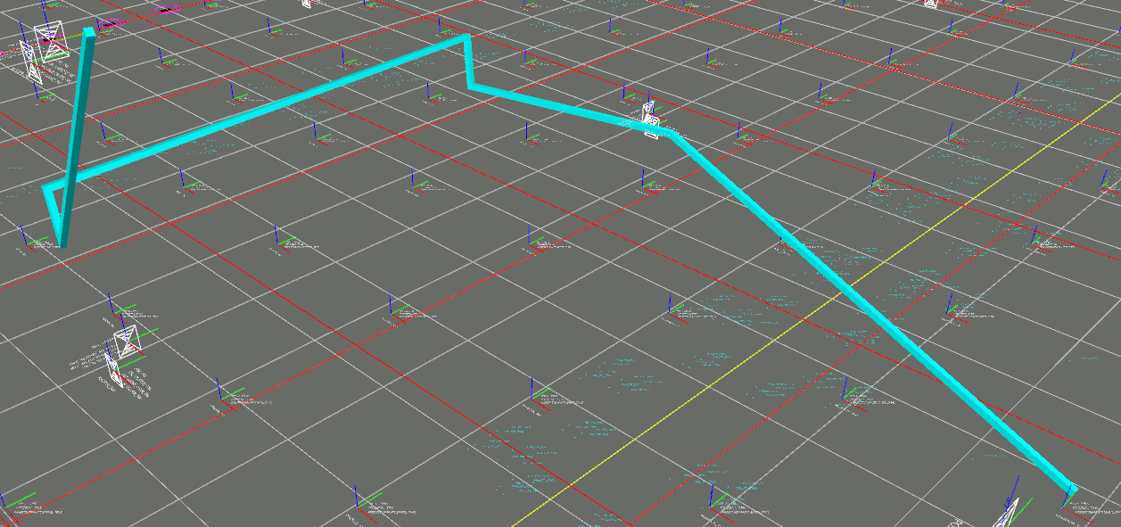  
First 9 point route made with Routing process

While Brandon set about getting the AT-960 set up to emulate field use with long (i.e. 600 mm [23 inch] probes) I setup 3Ddisto.

First 3DDisto data collection at column AA-26

Column AA-24, & 25, AB-25 was measured at center of column label dash or Target (verify later)

Coordinates of control data required formatting, studying & some trial and error to verify our importing was providing correct output. At-960 use Spatial Analyzer, 3Ddisto used specific software provided with unit.

3Ddisto would not accept large coordinates in feet. X=6146.9791, Y=8926.4688, Z=111.00 (find out why)

Remainder of day was spent getting familiar with subfab, control files, verifying control measurements, and setting up a process.

Using the laser scanner mount we determined a number of supplies were required which HP did not have on hand. I went to Lowes that afternoon and geared up.

We also realized two files would be required, one listing all control for the AT-960 in ASCII, and an AutoCAD 3D files of the control to import the results into. These were prepared in the subfab at an empty table available from Harder Mechanical.

We spent a lot of time “dry running” the measuring process, transfer of data, sweeping simulated routes and feeling our way around the process.

### Sept 6, 2019

AT-960 Start

9:00 AM Start of Probe calibration to the probes we would use. This is a one-time activity until you get a new probe.

9:35 AM calibration finished.

9:36 AM move AT-960 and start. (AT-960 ready to measure at 10:05 AM)

Using two men (Brandon Neer & Macaulay Christian) and a 3” disk held on the FPOC

AT-960 measured 53 FPOCs using six points per FPOC. Method was to use 3” PVC pipe cap, three points along circumference and three along “plane” in order to calculate absolute center.

On hour with two men yielded 53 locations. Average of 1 minute 8 seconds per point.

9:40 AM – Begin intermittent measuring with 3Ddisto up on top of catwalk unistrut.

|  |  |
| --- | --- |
| Point | Description |
| 1 | AA-27 west side |
| 2 | AA-26 east side |
| 3 | Z-25 ( determine side) |
| 4 | (Secure Point) Y-24 |
|  | Tilt Check runs due to vibration |
| 5 | Z-23 (Secure Point) |
| 6 | Start Fire pipe tracing route. This is the end cap of a “T” up from a main. |
| 7 | Head location |
| 8 | Head Location |
| 9 | Cap |
| 10 | Bottom of “T” |
| 11 | “T” going up from main |
| 12 | A hanger |
| 13 | Hanger at popout slab |
| 14 | Seismic Brace |
| 15 | “T” going up |
| 16 | “T” going up |
| 17 | Hanger Location |
| 18 | “T” going up |
| 19 | Hanger Location |
| 20 | “T” going up |
| 21 | Hanger Location |
| 22 | “T” going up |
| 23 | 6” from north and west sides of Popout opening. Measured the “grate” at the top as though a duct was starting at the grate below RMF. |
| 24 | Shot on bottom of popout slab for elevation purposes. |
| 25 | Shot on Unistrut embedded in slab close to column. |
| 26 | Shot on unistrut embedded in column. Shot is below slab to show elevation we’ll start a direction change from vertical to horizontal. |
| 27 | Shot where we’ll go down vertically |
| 28 | Shot where we connect to a FPOC Finish at 10:19 AM |
|  |  |
| 28 Measurements, 9:40 to 10:20 is 40 minutes. 1.428 minutes per measurement [85.71 seconds] | |

Second 3Ddisto session

11:25 AM relocate 3Ddisto

|  |  |
| --- | --- |
| Point | Description |
| 1 | AA-25 at popout slab |
| 2 | AB-25 at popout slab |
| 3 | 6” PVC FPOC in catwalk rack |
| 4 | Shot on bottom of popout bottom |
| 5 | Shot on popout slab |
| 6 | Shot on popout slab |
| 7 | Shot on unistrut top |
| 8 | Shot on unistrut top |
| 9 | End with shop on another 6” PVC FPOC in catwalk rack |
|  | 11:36 AM end and export |
|  | 9 points in 11 minutes or 1.22 minutes per point. |

AT-960 stop measuring at noon. 10:05 AM to 12:00 Noon 1 hour 55 mins [115 mins – 53 FPOC’s (3 measurements per FPOC – 2.16 mins per FPOC.

Measured 53 FPOC’s using two men and six points per FPOC out of sight. Using 600 mm probe.

Restart AT-960 at 1:50 PM shooting single points on Hidden FPOC’s with a single operator. Brandon Neer used AT-960 and T-probe to measure single point per FPOC.

Macaulay Christian and I used 3Ddisto mounted high in unistrut to measure Points using “offset method” in order to gather metrics on measuring point not within line of sight, i.e. hidden points. I also wanted to see how Macaulay Christian, who had never used the 3Ddisto, would operate it and take measurements. (How quickly can a novice operator measure points)

Restart 3Ddisto at 1:55 PM (180906-009)

|  |  |
| --- | --- |
| Point | Description |
| 1 | AB-25 West Target 6’ AFF |
| 2 | AA-24 South Target 6’ AFF |
| 3 | AA-25 South Target 6’ AFF |
| 4 | (Had Macaulay Christian measure until 2:35) Wanted to have someone who never saw the unit or the software take instruction remotely while I directed him through the camera where to measure. All remaining points captured in Point exports. |
|  |  |

AT-960 stopped measuring at 2:50 PM, Brandon reported measuring 320 FPOC’s.

points minutes Pt/min secs/pt Chk

320 60 5.333333333 11.25 320

End at 3:20 in order to adhere to schedule of getting equipment transported to dock and keep escorts on quit time of 4:00 PM.

Raw Data table from 3Ddisto:

Sept 4, 10:57 AM



Routing Points:

|  |  |  |  |
| --- | --- | --- | --- |
| East(X) | North (Y) | Elev (Z) | Point |
| 27000 | 100000 | 1277 | 180903_0001 |
| 21909.397 | 100000 | 1257.934 | 180903_0002 |
| 23459.904 | 99239.898 | 1267.678 | 180903_0003 |
| 23453.566 | 97822.919 | 1274.921 | 180903_0004 |
| 23458.054 | 97820.32 | 210.481 | 180903_0005 |
| 23461.196 | 99184.827 | 123.912 | 180903_0006 |
| 23851.641 | 100009.367 | 1112.628 | 180903_0007 |
| 26978.718 | 100003.65 | 582.395 | 180903_0008 |
| 28304.733 | 102369.387 | 793.789 | 180904_0009 |
| 29555.898 | 103126.082 | 1759.522 | 180904_0010 |
| 29353.666 | 102217.247 | 627.451 | 180904_0011 |

Graphic representation of measurements as routes:



2019_09_04.1.dwg

Eleven points collected and converted in 15 minutes. One minute 21 seconds per point. Setup time to mount equipment in subfab 3 feet below popout slab was 3 minutes.

( To reduce clutter I will only show remaining data in graphic form, all data collected with same process.)

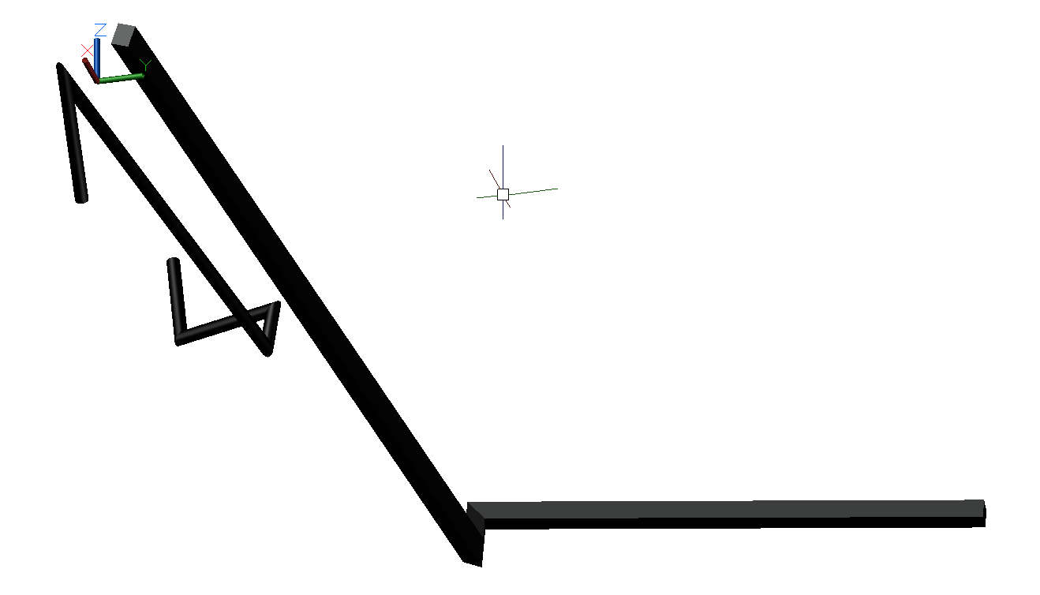

2019_09_06.1.dwg

28 points collected and converted in 32 minutes. 1 minute 8 seconds per point.

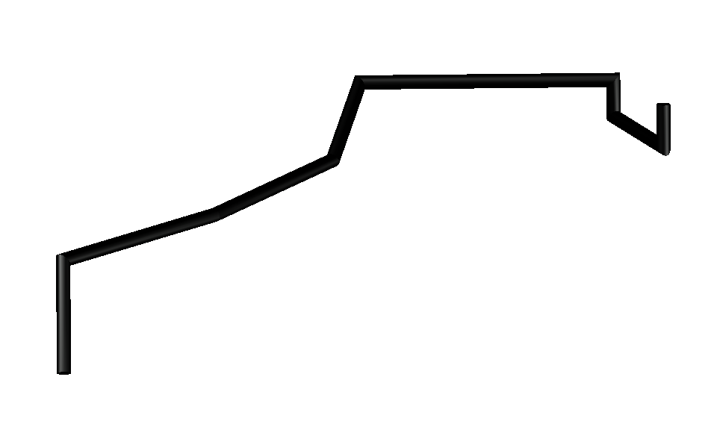

2019_09_06.2.dwg

9 points collected and converted in 8 minutes. 0 minute 53 seconds per point.

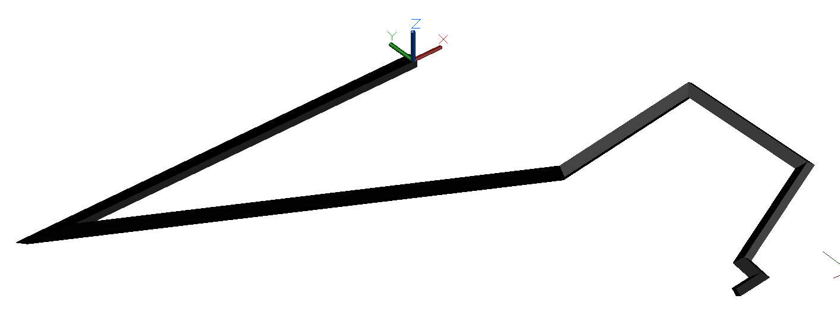

2019_09_06.3.dwg

8 points collected and converted in 8 minutes. 1 minute 0 seconds per point.

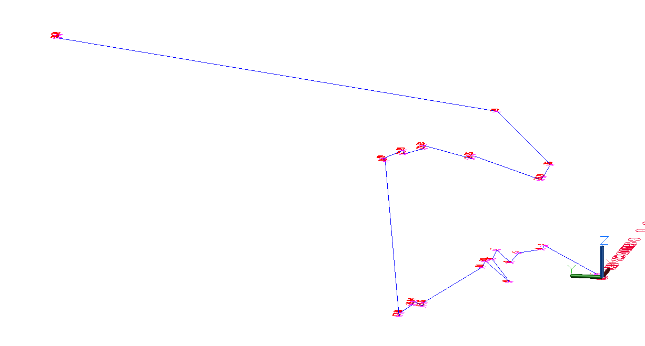

2019_09_06.4.dwg

31 points collected and converted in 38 minutes. 1 minute 13 seconds per point.

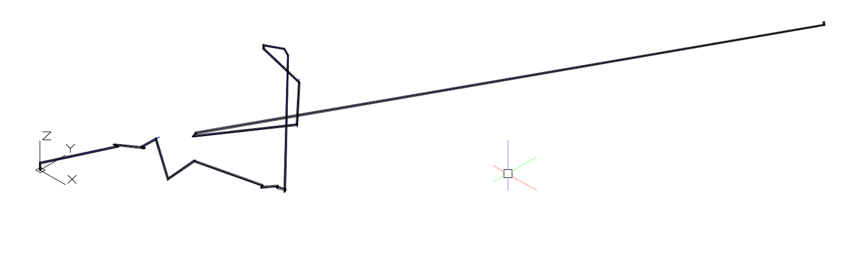

2019_09_06.5.dwg

31 points collected and converted in 41 minutes. 1 minute 19 seconds per point.

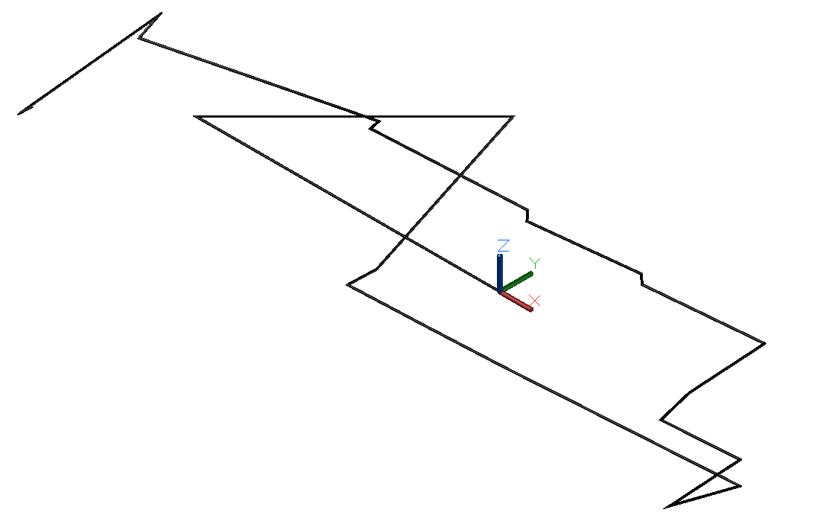

2019_09_06.6.dwg

24 points collected and converted in 28 minutes. 1 minute 10 seconds per point.

## Conclusions:

Leica AT-960 laser tracker Average time per point 2 min, 10 seconds per FPOC using six measurements per location, 11.25 seconds using a single measurement per FPOC.

Leica 3Ddisto Average time per point 1 min, 12 seconds.

|  |  |  |  |
| --- | --- | --- | --- |
| Points | Time (m) | Time(s) | Sec/Pt |
| 11 | 15 | 900 | 81.81818 |
| 28 | 32 | 1920 | 68.57143 |
| 9 | 8 | 480 | 53.33333 |
| 8 | 8 | 480 | 60 |
| 31 | 38 | 2280 | 73.54839 |
| 31 | 41 | 2460 | 79.35484 |
| 24 | 28 | 1680 | 70 |
| ------- | ------- | ------- | ----------- |
| 142 Total | 170 Total | 10200 Total | 71.83099 Total |
|  |  |  |  |
| Average |  |  | 1 min 12 seconds |

### Deductions:

General hypothesis on concept of measuring routes was verified with following exceptions:

Area being measured requires accurate list of control coordinates used by teams  
Personnel must use ladders, planks, and have fall protection certification  
Specialty lightweight mounts for equipment is required. Carbon Fiber is preferred.  
Any mounts will be tethered to unistrut as a fall protection safety measure  
Wireless hotspots will be required  
Electrical extension cords are required  
A specialty equipment cart should contain required equipment to eliminate transport & wipe down (takes too long to transport and set equipment)  
Specialty probes and offset jigs need to be fabricated (again carbon fiber or equally light weight strong and durable materials)  
Desk/Chair work area  
need Iphone or Tablets set up to work with equipment.

[Link to report graphics](http://lucrosol.com/node/90)

**Jim Park Comments:** I like the metrics on time taken to capture points. I’m not sure however if it accounts for other factors such as instrument setup time. This will add significant time when working in congested spaces (the area we were in is about the most open on the campus). If the main benefit of the approach is to assist tools that are at risk, it is safe to assume that most of those tools would be in taskforce and crawling with trade contractors day and night (that has been our experience scanning such tools).

It would be interesting to run some tests in an environment like Fab 12. We had a demo with Leica utilizing a robotic total station with limited scanning capabilities and a prism offset mechanism for scanning hidden POC’s. Given the somewhat limited access to brass caps in 12 and overall congestion, we were only able to shoot in on average 5-10 POC’s due to congestion from a single position. With that, we lost a significant amount of time with moving the instrument and running a resection.

When we first went out there were some issues setting up (due to issues with the control file). I wasn’t out there the last day, but I assume the process became much more efficient. An important metric would be how long it takes on average to set up the tracker, run power to it, and run the resection to establish the position of the instrument. This would provide a more accurate production rate as opposed to a capture rate.

An example of this would be with the laser scanner. At full speed, the scanners can capture nearly 1,000,000 points per second. That capture rate however is not continuous as it doesn’t include other factors such as setting up reference targets, positioning the scanner, and registration. I don’t think it would be feasible for someone to shoot in 1,600 POC’s in a shift (the 320 FPOC/hour rate * 5).

This was an important proof of concept, but I think running it in a more realistic space under realistic conditions would provide a much better representation of repeatable production rates. It would also help determine where and when the technology should be most effectively deployed.

[JPark@henselphelps.com](mailto:James.park@henselphelps.com)

Jim Park  
VDC Manager  
Corporate  
4129 East Van Buren Street  
Suite 100  
Phoenix, AZ 85008

480.356.6228

1. Software used requires three points to calculate a circle, three more to calculate a plane for the circle.
2. If you require accuracy within one quarter of a millimeter, or 250 microns, you can use a single point measurement.